**MICROFLUIDICS**

**Microfluidics:**

* The flow of fluid through a channel with dimension less than 1mm (1000µm)
* When a fluid flows through a channel, the flow may be turbulent or laminar
* The type of flow that occurs in microfluidic channel is characterised by **Reynolds number**

**Reynolds Number:**

**

where ,

L is the length of the channel

V is the average velocity flow

ρ is the density of the fluid

µ is the viscosity of the fluid.

**Laminar and Turbulent Flow**

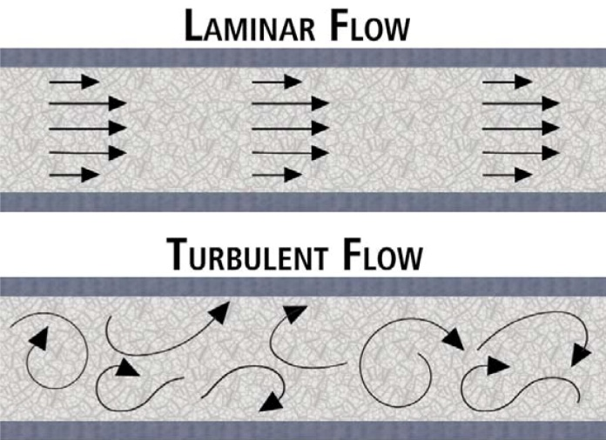

Re>4000

Re<2000

General steps to be followed while working on Comsol

1. Select Model Wizard

2. Select Space Dimension- Depending on the working model

3. Select Physics

4.Select Study

**2D Example:**

***Flow through a micro channel- 100X1000µm***

1. Select Model Wizard

2. Select Space Dimension- 2D

3. Select Physics - Laminar Flow

4. Select Study- Stationary

5.Geometry:

* Geometry settings- Length unit- Change to µm
* Right click on geometry- select Rectangle
* Enter the width -1000, height-100
* click build select

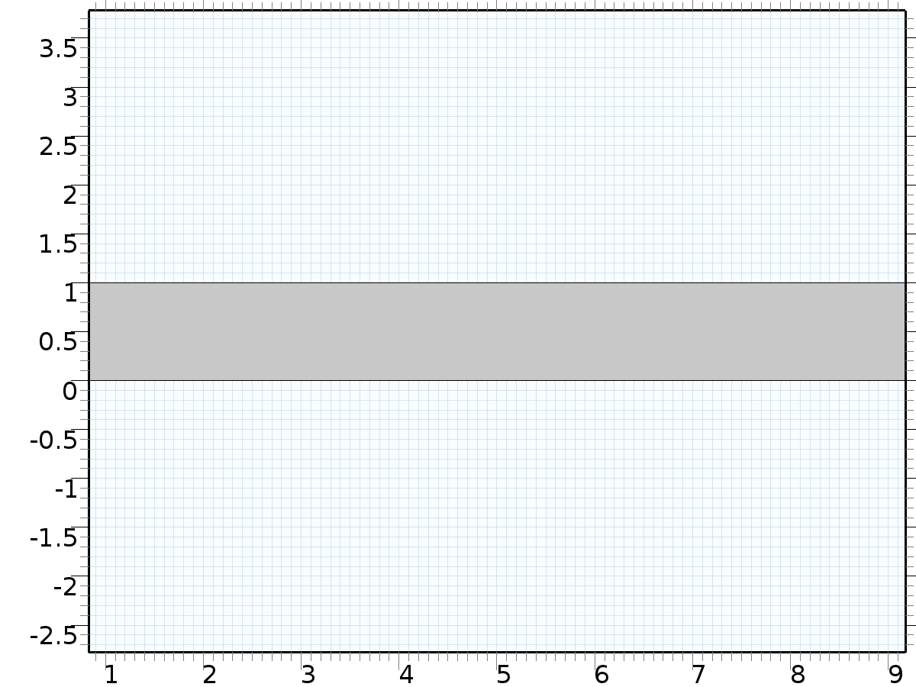

6. Material Selection:

* Right click on material- select add material-liquid & gases- water- click add to component on top

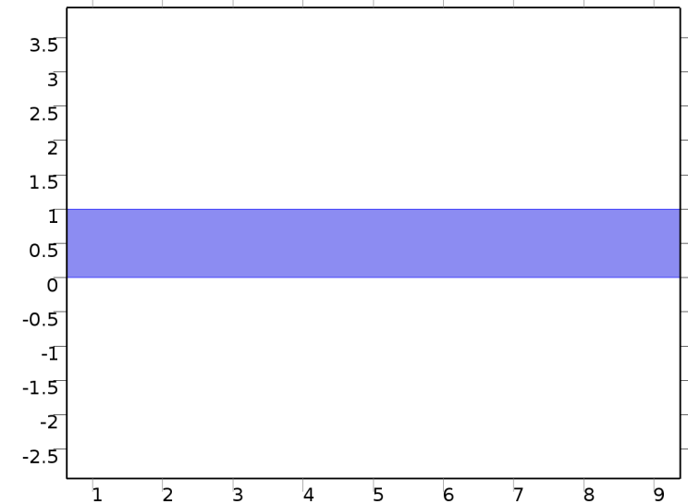

7. Boundary Condition:

* Right Click on the physics(laminar flow)- Inlet - settings- select boundary - velocity --Normal inflow Velocity- 1m/s

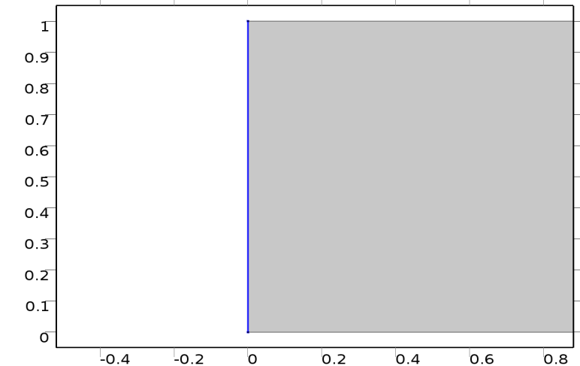

* Right click on Physics(laminar flow)- Outlet - settings- select boundary- Pressure- 0m/s

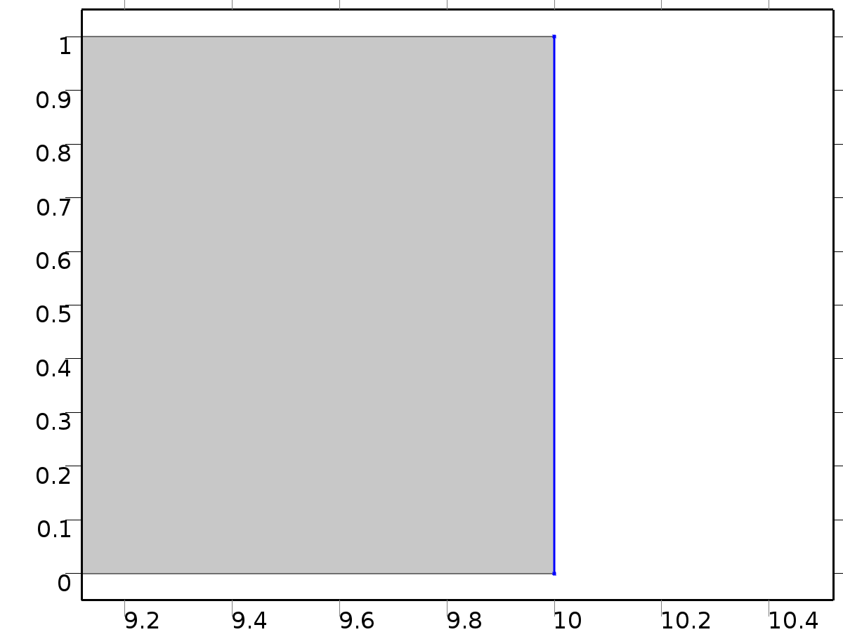

8. Meshing:

* Click on meshing - Setting- Element size- Extremely coarse- Click build all

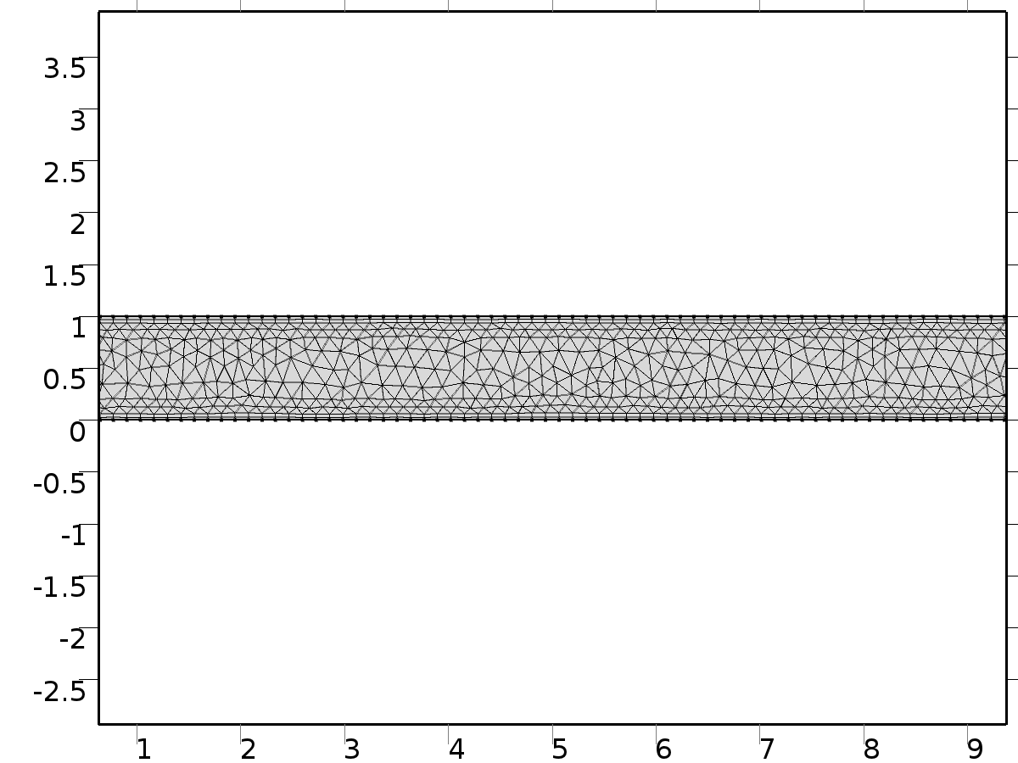

9. Study:

* click on study- settings-click compute

10. Result:

* Velocity- Right click on velocity- Select stream line- Setting- stream line positioning- magnitude controlled- click plot

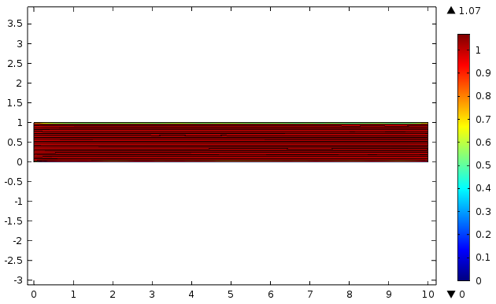

Pressure

